GGKLI September 23, 2012
GROUP 3 and 4
Yagna

- Yagna means selfless sacrifice for noble purposes; Sacrificing the ego, selfishness and material attachments.
- Yagna teaches living in a society in harmony and a lifestyle to promote and protect higher humane values in the society.
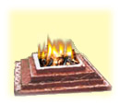
- Yagna comprises of three elements:
- Worship of Gods - Appreciating noble qualities
- Togetherness - Unity
- Charity - Welfare/Donation

Types of Yagna

- Seva Yagna- altruist service of the society
- Gnana Yagna- service of people by enlightening their lives in the glow of knowledge and education
- Prama Yagna- saving the lives of people suffering and in agony and inspiring liveliness and respect for life in them

Things Used in Yagna

- Wood- sandalwood, pipal, mango
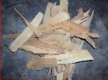

- Havankund


- Odoriferous Substances- saffron, musk, camphor

- Substances with Healthy Constituents- milk, clarified butter, fruit, & grains such as rice

- Sweet Substances- sugar, dried grapes, honey

- Medicinal Herbs- somalata, brahmi, shankhpushpi, nagkesar, mulhati

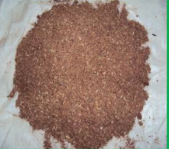

Science and Yagna

- Industrial wastes, rapid urbanization, deforestation, air and water pollution, disturbances in the ozone layer formation, and radioactive waves have destabilized the human, animal and plant life cycles. The ecological imbalances caused by these acts of ‘civilized men’ has resulted into a disastrous threat to the entire planet.

- Experimental studies show that the incidence of physical ailments, sickness and disease are reduced in the houses where the Yagna (Agnihotra) is regularly performed because it creates a pure, nutritional and medicinal atmosphere. It renews the brain cells, revitalizes the skin, purifies blood and prevents the growth of pathogenic organisms.
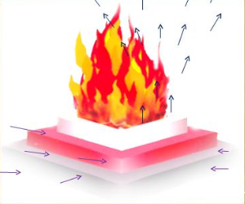

- Cow’s milk contains great power of protection from atomic radiation
  - If cow’s ghee is put into the Yagna fire, its fumes lessen the effect of atomic radiation to a great extent.

- Removes foul odors- Various oils such as camphor and clove diffuse into the atmosphere

- Removes bacteria- The oxidation of hydrocarbons during Yagna produces formic acid and acetic acid, both of which are good disinfectants.

- Removes insects- Non-bacterial parasites either get killed or are driven away when they come in contact with volatile oils such as camphor

- Affects plants and animals- The ash from the Yagna serves as a natural fertilizer and maintains ecological balance.

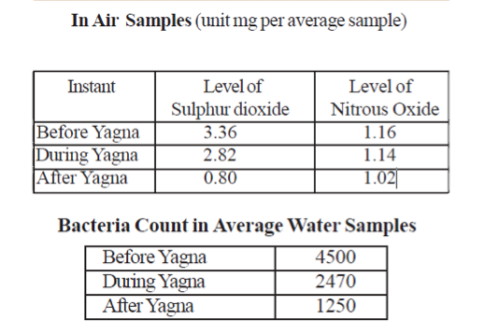

Mantras and Yagna

- The collective chanting of Mantras in specific rhythm in front of the Yagna flames gives rise to unique sound waves which have infinite radiant effects in the outer space.
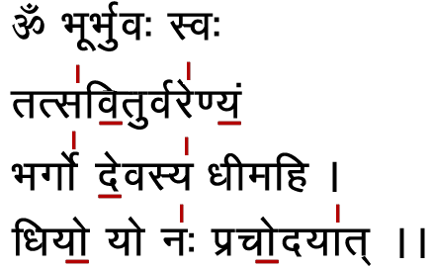

Medical Uses of Yagna

- Yagna can be used to treat:

    - Malaria
    - Hypertension
    - Diabetes
    - Asthma
    - Cardiac Problems
    - Mental Disability
    - Arthritis
    - Cancer
    - Aids
